Knee to wall test

Place a tape measure along the floor perpendicular to a wall.

Adopt the position shown in the picture with your foot 6 cms away from the wall. Ensure that your foot is flat on the floor and your pelvis and shoulders are facing the wall. Put your hands on the wall for balance. Keeping your foot flat on the floor, slowly move the knee of the front leg closer to the wall until your knee cap touches the wall. If your knee reaches the wall without your heel lifting from the floor, then move your foot back 1 cm and repeat. Find the maximum distance you can move your foot away from the wall and still reach the wall with your knee cap without the heel lifting. Record this distance in the chart below.

Use the exercises overleaf to help mobilize your ankle and increase this range of movement.

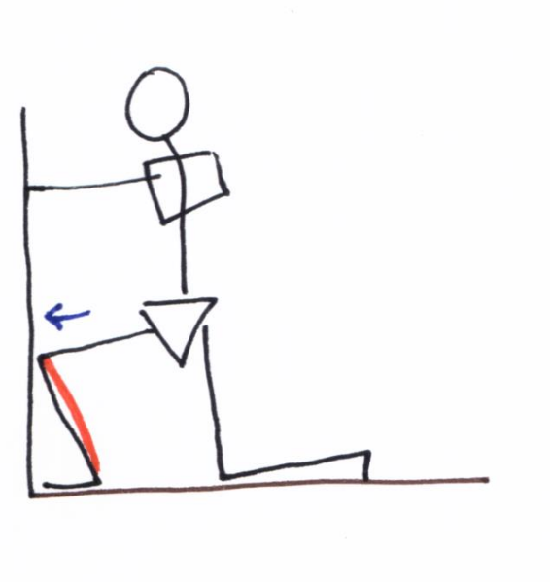

|  |  |  |
| --- | --- | --- |
| Stiff | Normal | Hypermobile |
| <6 cms | 10 – 12 cms | >12 cms |

Record your progress here. Measurements in cms

|  |  |  |  |  |  |  |  |  |  |  |
| --- | --- | --- | --- | --- | --- | --- | --- | --- | --- | --- |
| Date |  |  |  |  |  |  |  |  |  |  |
| Left |  |  |  |  |  |  |  |  |  |  |
| Right |  |  |  |  |  |  |  |  |  |  |

|  |  |
| --- | --- |
| Goal: |  |
| When your goal is achieved, make new physio appointment | |

Rehab exercises

**FUNCTIONAL TEST: ANTERIOR REACH.**

Stand on the test leg and reach with control as far forward as able without lifting the heel of the test leg. Record this distance.

**EXERCISE 1:**

Repeatedly reach forward to a point approx.. 80% of your maximum reach. Add distractions like throwing and catching a ball

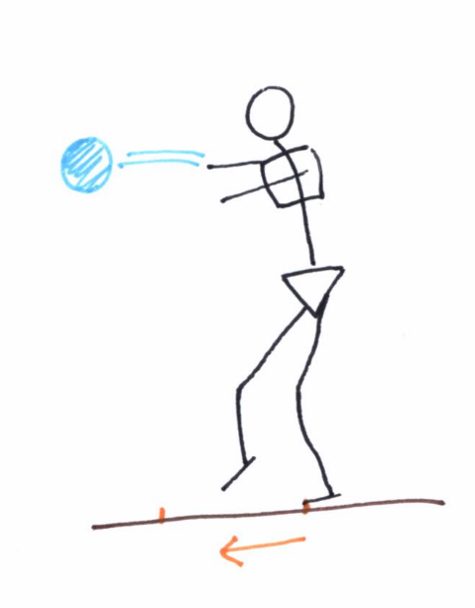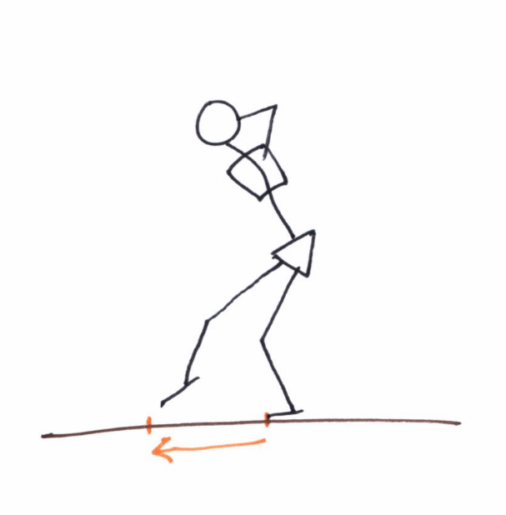

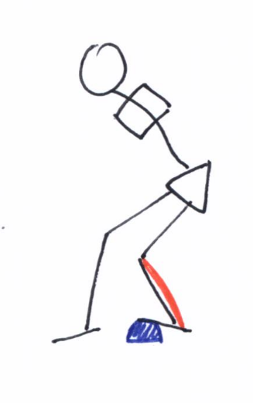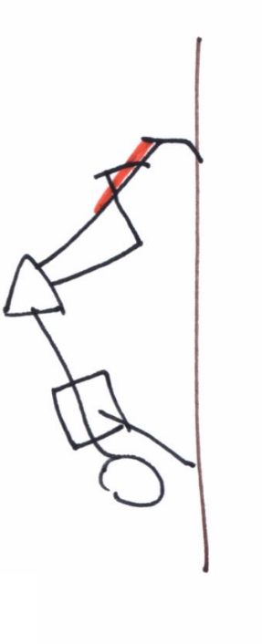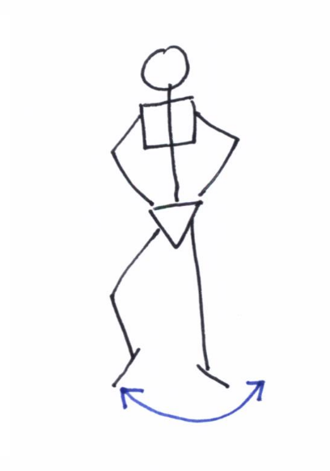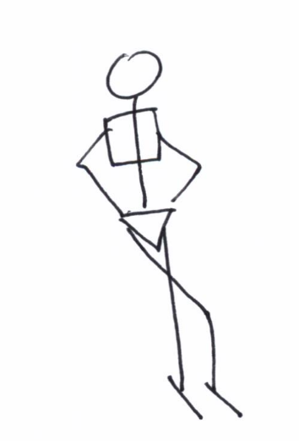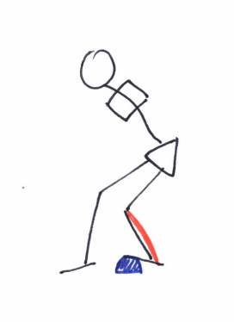

**EXERCISE 4:**

Ankle joint mobility

**EXERCISE 3:**

Calf muscle tissue stretch

**EXERCISE 2:**

Stand on the exercising leg and make a big rainbow with the opposite foot on the ground. This will encourage you to move onto the edges of your foot.