**HAMSTRING**

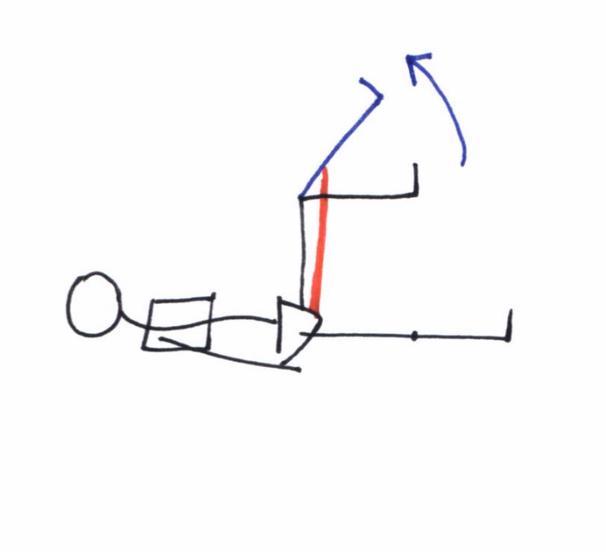**MOBILITY**

**TEST:**

Lay on your back with your hip at 90 degrees flexion. Hold this position and try to straighten your knee as far as possible without any hip movement. Use this as an exercise to increase hamstring lengthening.

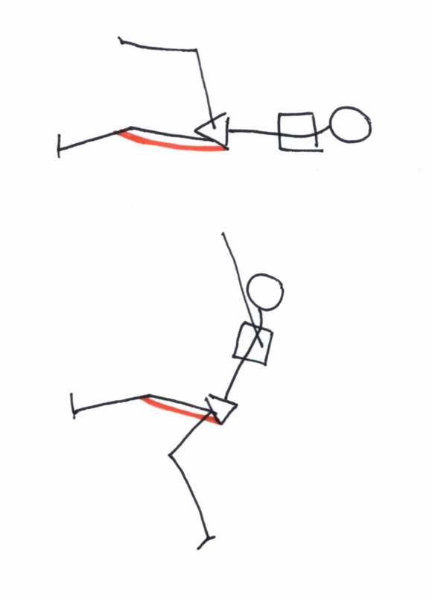

EXERCISE 1: Waiters Bow

A

B

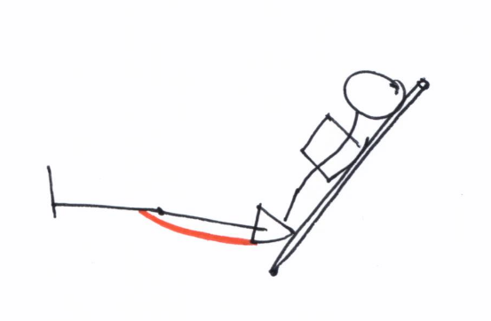

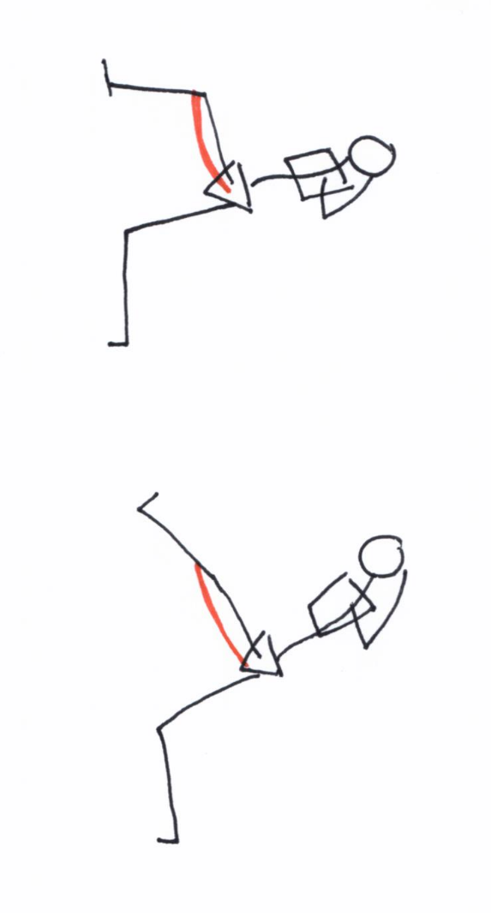

EXERCISE 2: Single leg waiters bow

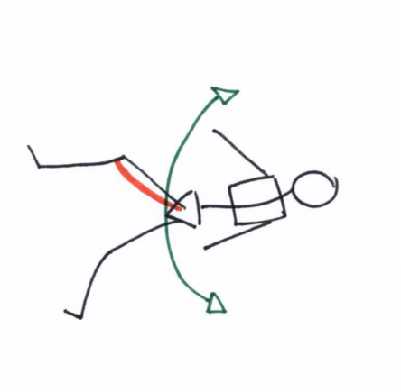

B

A

EXERCISE 4: Bow saw

EXERCISE 3: Kneeling mobility